 | Year 12 Specialist  TEST 4  Weds 28 Aug 2019  TIME: 50 minutes working  Classpads allowed  No notes allowed  45 marks 8 Questions

Name:_______________________________

Teacher: ____________________________

Note: All part questions worth more than 2 marks require working to obtain full marks.

Q1 ( 3, 3 & 3 = 9 marks)
Determine the following integrals using the given substitutions.

Solution
Specific behaviours
subs du
integrates wrt u
expresses answer in terms of x only with a constant

Solution
Specific behaviours
subs du
integrates wrt u
expresses answer in terms of x only (no need for constant)

Solution
Specific behaviours
subs du
integrates wrt u
expresses answer in terms of x only (no need for constant)

Q2 (3 marks)
Identical twins Sherry and Mary were both given the following integral to solve.
Sherry’s solution was as follows.

While Mary’s solution was to:

Explain why the solutions differ and state which is the correct answer. Show your reasoning.

Solution
Both missing constants
Constant differ
Both answers correct as

Specific behaviours
mentions that constants missing
states that constants are different
shows that both expressions differ by an added constant

Q3 (3 & 4 = 7 marks)
Determine the following integrals showing all working.

Solution
Specific behaviours
integrates using ln
uses absolute value
determines result

Q3 cont-

- (4 marks)

Solution
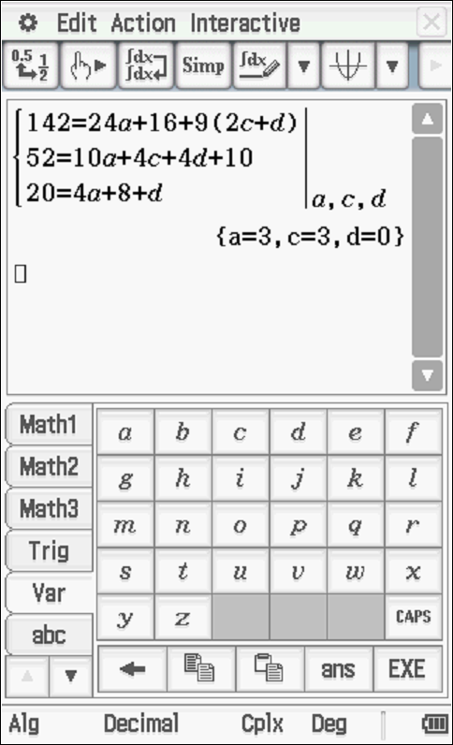

Specific behaviours
uses correct partial fractions with 4 constants
solves for at least one constant
sets up simultaneous equations for other constants
integrates correctly (no need to add c)

Q4 (5 marks)
The shaded region is rotated about the y axis. Determine the volume of the resulting solid.

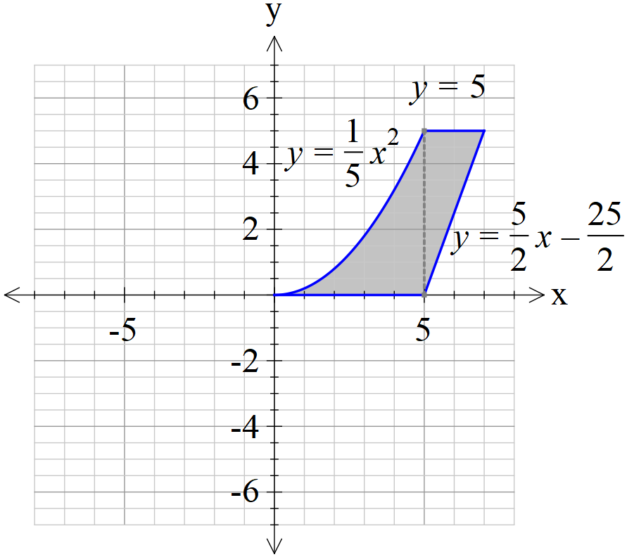

Solution
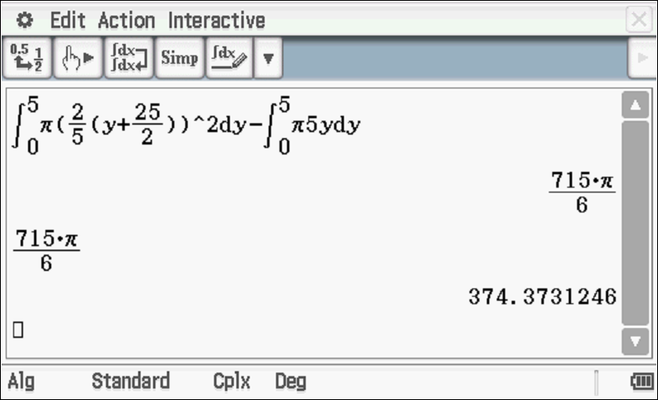

Specific behaviours
uses correct integral around y axis
uses correct limits
sets up a difference calculation with volumes
states correct approx. volume

Q5 (1 & 4 = 5 marks)
The mass, grams, of a gas produced in a factory at time seconds can be modelled by the logistical formula with an initial mass of 0.1 grams.
- Determine the limiting mass as .

Solution
Specific behaviours
states limiting value

- Show that and determine the constant.

Solution

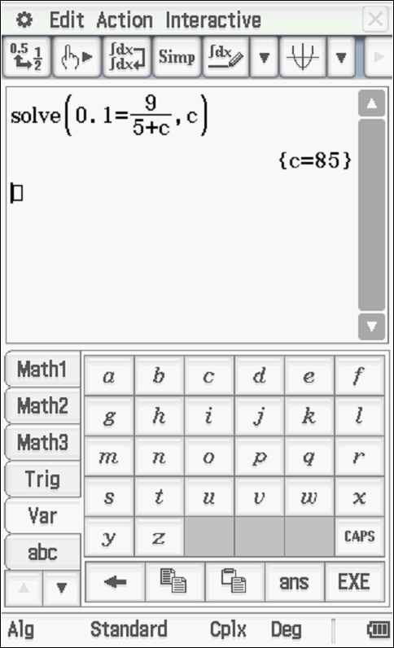

Specific behaviours
separates variables
sets up partial fractions
integrates and shows why absolute value not needed
solves for constant

Q6 (3 & 3 = 6 marks)

- Sketch the slope field for on the axes below.

Solution
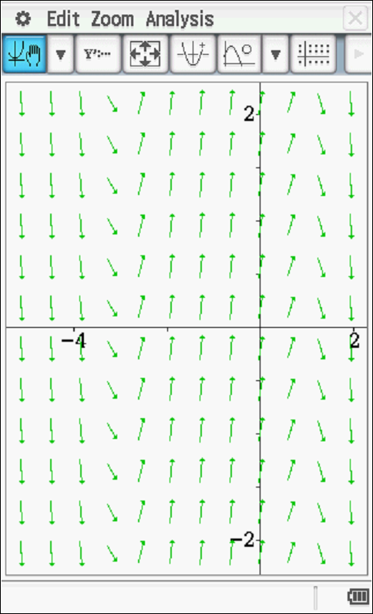

Specific behaviours
shows one zero
shows both zeros
pattern agrees with above

- Given that point A (-1,1) is a known point on our solution, show this curve on the slope field above and give the equation.

Solution
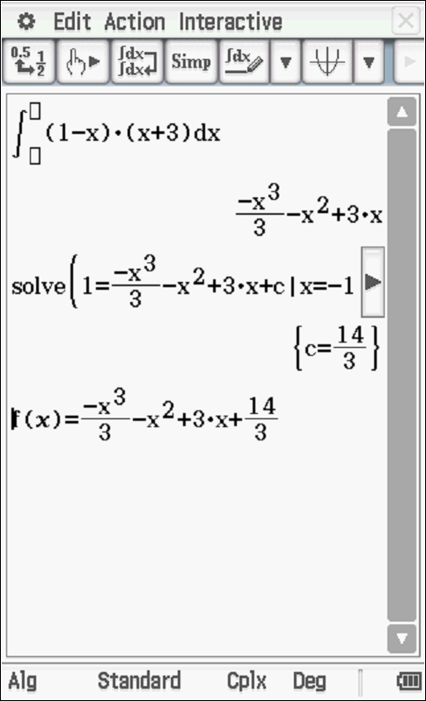

Specific behaviours
shows curve on slope field going through pt A
integrates slope field
solves for constant

Q7 (2, 3 & 2 = 7 marks)

A particle with displacement, metres from the origin at time seconds, moves such that .
- Show that the motion is simple harmonic.

Solution
Specific behaviours
obtains acceleration function
shows correct differential equation for SHM

- Determine the first two times that the speed is exactly half of the maximum speed.

Solution
t=0 v=5m/s
v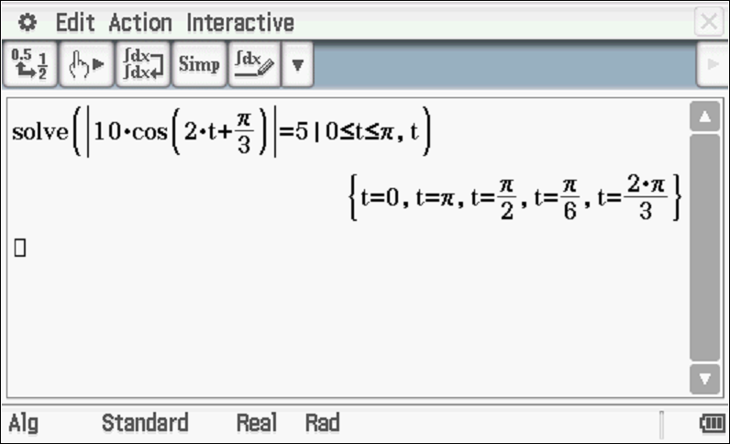

First two times are
Specific behaviours
states initial time
uses negative velocity for second time
solves for second time, approx

- Determine the distance travelled in the first 3 seconds.

Solution
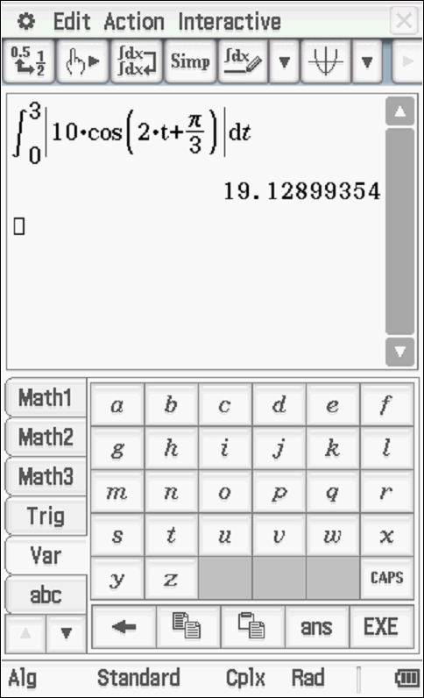

Specific behaviours
uses correct integral with absolute velocity
states distance travelled

Q8 (4 marks)
A particle with displacement, metres from the origin at time seconds, has an acceleration given by . The amplitude of the motion is given by metres.
Show by using integration that the speed, metres per second, is given by .

Solution
Specific behaviours
uses alternative expression for accleration
uses separation of variables
integrates correctly
solves for constant in terms of A & n

